Spanish Placement Exam Norming

## Data Analysis

4/27/2018

There are 243 students in the dataset, distributed as in the table below (0=failing course grade, 1=passing course grade). There appear to be a much larger number of failing course grades in SPAN 2110. (23 students below 60% in SPAN 2110, compared to 2, 2, 6, and 6 students below 60% in the other levels, respectively.

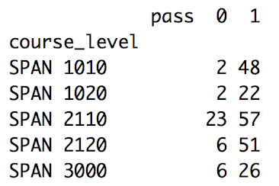

Total number of students that took the placement exam for each course:

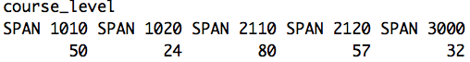

All 13 students from a section of SPAN 2110 are excluded in the following analyses because their course grades from D2L are all below 50% (likely due to incorrect denominator in D2L). Remaining N=230.

### Distribution of placement scores by course_level and pass (1) vs. fail (0). Including outliers.

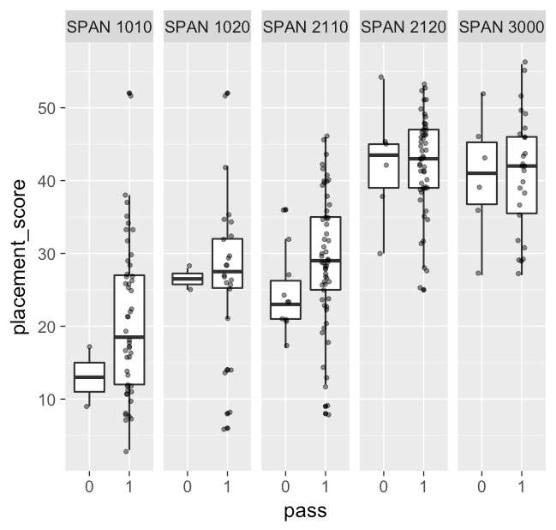

### Distribution of placement scores by course_level and pass (1) vs. fail (0). Excluding 4 high-scoring outliers and including low-scoring outliers. The rest of the analysis excludes these 4 high-scoring outliers. Remaining N = 226. (Outlier criteria is > 1.5*IQR above the 3rd quartile).

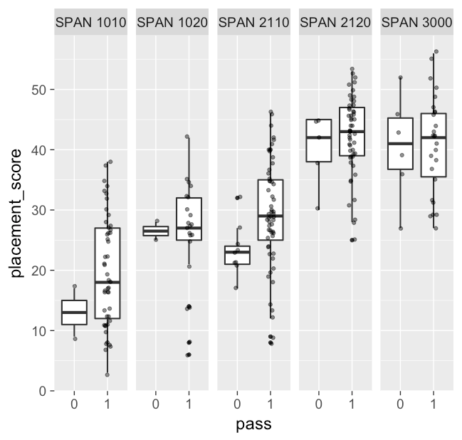

### Placement Score by course level and D2L course grade. Blue lines are regression lines of best fit. Within each course level, course grade and placement score are correlated, such that higher course grades are associated with higher placement scores (as expected).

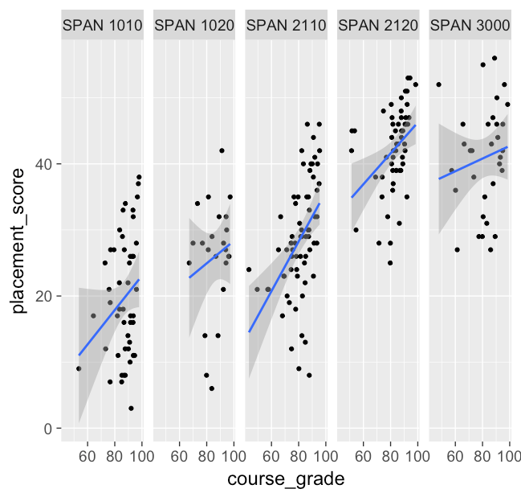

### Placement Score by course level and D2L course grade, combined into a single plot. Colored lines are regression lines of best fit for each course level.

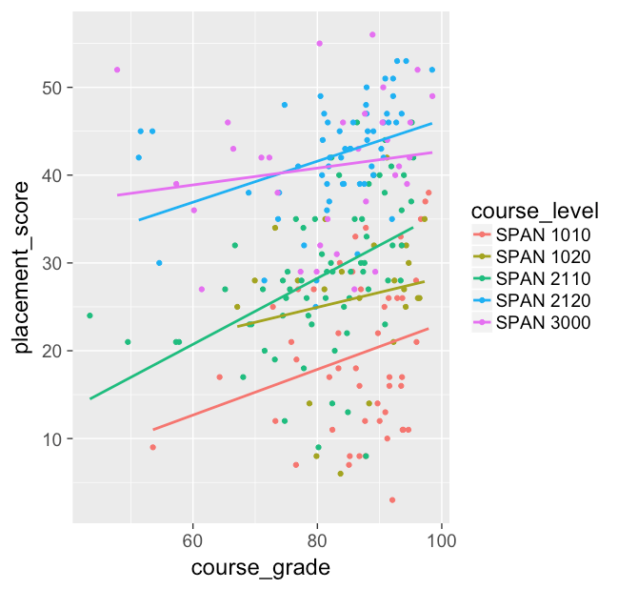

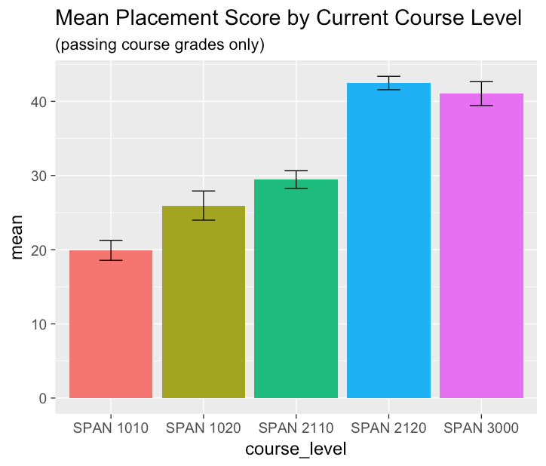

Error bars indiciate standard errors.

Table of placement scores by current course level (passing course grades only).

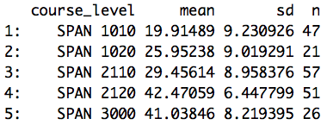

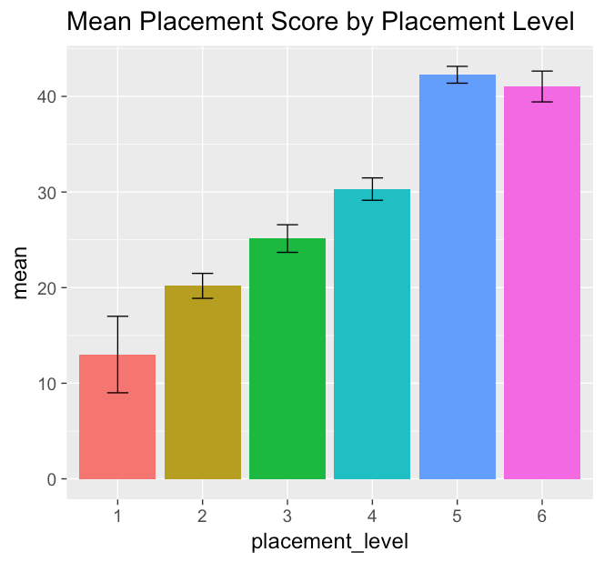

Error bars indiciate standard errors. Placement levels indicate the course level a student should be placed into. For example, placement level 2 means a student should be placed into SPAN 1020, and placement level 4 means a student should be placed into SPAN 2120. Placement levels were created by grouping students with passing grades from the previous level with students with failing grades from the current level. For example, placement level 3 includes students from SPAN 1020 with passing grades and SPAN 2110 with failing grades.

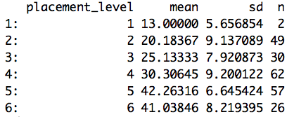

## Methods for setting cut scores

* For review of common methods, see <https://eric.ed.gov/?id=ED562865>
* Placement test structure: 60 Questions Total
  + 15 questions from each of 4 levels, that everyone will have learned by the end of that level
  + A priori expectations: 15 Q’s correct/level + guessing?
* **Borderline Group Method** -- Categorize students into adequate, inadequate, and borderline groups based on course grade. The median of borderline group’s scores on the placement test is defined as the cut score.
  + If most of the test scores of the borderline group are clustered close together, then the method is working well.
  + What should be the course grade cutoffs for adequate, inadequate, and borderline?
* **Contrasting Groups Method** - Categorize students into qualified and unqualified groups based on course grade. Consider all test takers with a particular test score (or interval of test scores) and ask, “are the majority of them qualified or unqualified?”. Cut score determined as placement test score at which there are just as many qualified as unqualified test-takers.
  + Can also set cut score at different proportions of qualified vs. unqualified test-takers, based on relative costs of error types. For example, if it’s twice as bad to place a student too low than too high, then the cut score should be set at the placement test score where there are exactly two unqualified test-takers for every qualified test-taker.
  + Need to smooth proportions for each test score interval
  + Alternatively, plot score distributions for two levels (e.g., level 1 vs. level 2) and set cut score at the point where the two distribution curves intersect.
* **Logistic Regression Method -** Similar to contrasting groups method, but uses logistic regression to fit curve to proportion of qualified students at each score interval.
* **Ordinal Regression** - similar to Logistic Regression method, but takes into account order of the groups, instead of just treating each group as a nominal category

In the histograms below, the lower placement level is always in red, and the higher placement level is always in blue. Cut scores are set by a mixture of borderline, contrasting groups, and ordinal regression methods.

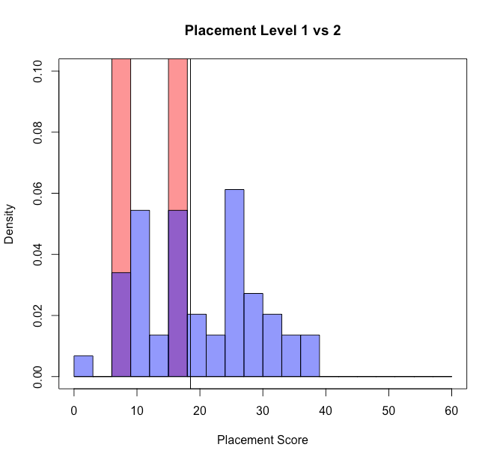

cut score ~ 18.5 (vertical line)

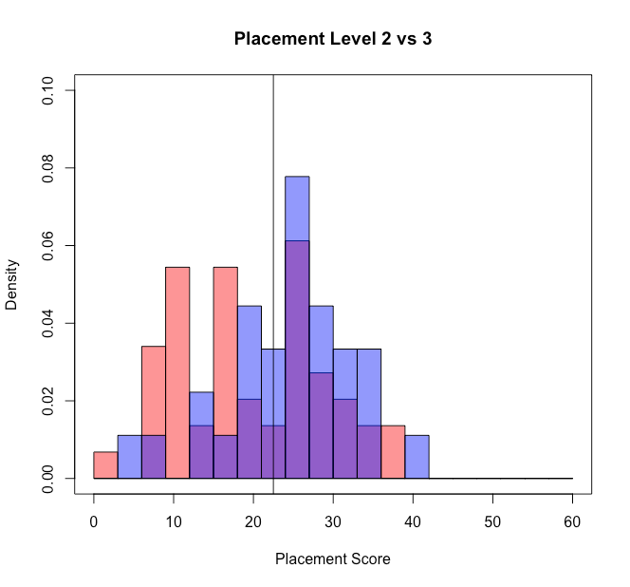

cut score ~ 22.5 (vertical line)

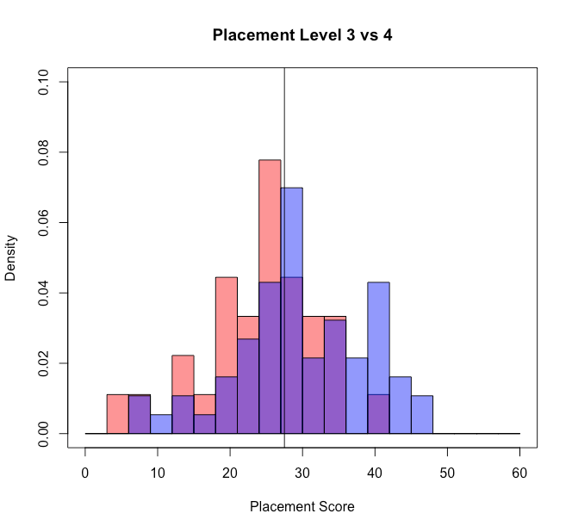cut score ~ 27.5 (vertical line)

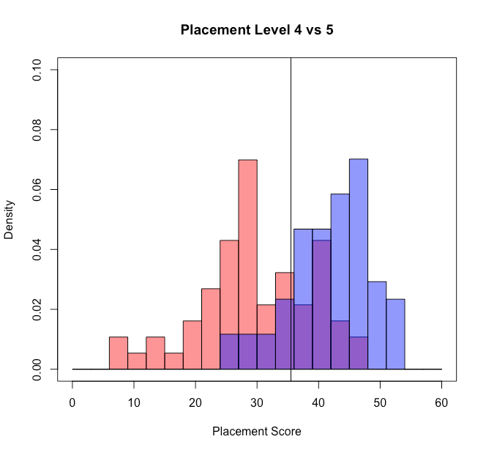

cut score ~ 35.5 (vertical line)

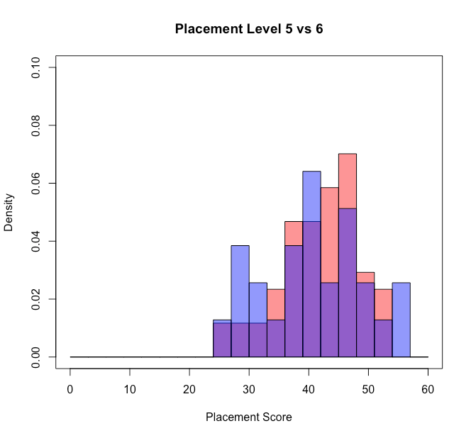

|  |  |
| --- | --- |
| **Interpreting Your Placement Exam Score** | |
| **Score between 0-18 out of 60** | Spanish 1010 |
| **Score between 19-22 out of 60** | Spanish 1020 |
| **Score between 23-27 out of 60** | Spanish 2110 |
| **Score between 28-35 out of 60** | Spanish 2120 |
| **Score between 36-60 out of 60** | Spanish 3000 |

Link to supporting R code: <https://github.com/jmfoster/spanish_placement>